(Approx. 331 words)

Graphical Disk Usage Analyzers
By Cal Esneault, Co-Editor, Workshop & SIG leader,
Cajun Clickers Computer Club, LA
July 2018 issue, Cajun Clickers Computer News
www.clickers.org
tsa70785 (at) gmail.com

If you use a Linux distribution based on GNOME (such as Ubuntu or Linux Mint), included software should have a program called Disk Usage Analyzer which gives a menu-driven, graphical representation of file usage on any disk drive. This application, originally part of gnome-utils, has been stand-alone since GNOME 3.4, and its original name was Baobab (like the tree).

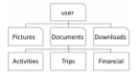
Computer files are organized into “tree” structures which have directories (folders) and sub-directories (sub-folders). A simplified example is shown to the right. We can ex amine the size of each folder individually to see space used. To get a better feel for larger sections, programmers have developed a variety of graphical representations. The Baobab approach use a series of rings (each ring is another directory level) where ring size depicts file storage usage. Below is a screenshot of one of my Linux systems. Using the left-hand pane, you can select any sub-folder for more detailed review.
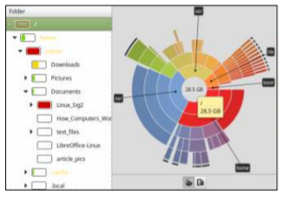
This display not only shows general usage, but it also gives you an idea of the structural fragmentation of your hierarchical arrangement. As you click on different sub-directory rings, the text will change to show those areas in more detail.

Selecting large portions can at times be overwhelming. Below are two examples where the left-hand panel was changed to select sub-folders.
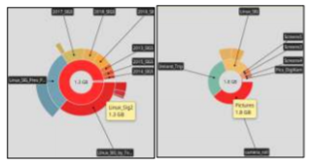
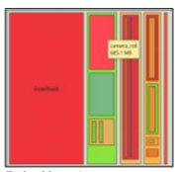
As well as this “ringmap” display, the information can be displayed using a “treemap” chart (see on right). This works well to find areas using a lot of space, but it requires lots of “clicking” to determine what you are really looking at.

There are many other graphical tools to check you disk usage. For example, GdMap (see below) is an even more sophisticated treemap tool.
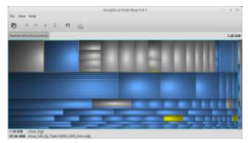

Similar tools are also available for Mac OS and Windows. Try one out and improve the efficiency of you disk storage.

